ZUG Installation Guide
Whilst all reasonable care has been taken to ensure that the details are true and not misleading at the time of publication, no liability whatsoever is assumed by Automature LLC, or any supplier of Automature LLC, with respect to the accuracy or any use of the information provided herein.
Any license, delivery and support of software require entering into separate agreements with Automature LLC.
This document may contain confidential information and may not be modified or reproduced, in whole or in part, or transmitted in any form to any third party, without the written approval from Automature LLC.
Copyright © 2010 Automature LLC
All rights reserved.
Revision History
Ver. | Date | Name | Description of Changes
1 | 2010-09-20 | Nitish Rawat | First Revision
2 | 2010-09-29 | Dipayan Sengupta | Revised Edition
3 | 2010-03-10 | Nitish Rawat | Revised Edition
4 | 2010-12-02 | Nitish Rawat | Revised Edition
5 | 2011-08-30 | Sankha Sil | Revised Edition
6 | 2011-01-05 | Sankha Sil | Revised Edition
7 | 2012-10-11 | Dipayan Sengupta | Updated SnapShots
8 | 13-01-02 | Md Sarfaraz Khan | Added a trouble shooting , JRE dependence
Content
Table of Contents
1 Introduction 4

1.1 Document Purpose 4

1.2 Intended Audience 4
2 System Requirements 5
3 Installation Instructions 6

3.1 Zug installer download 6

3.2. Initialization of Zug installation 7

3.3 Completion of Installation 9

3.4 Version Verification 9
4. License Activation 11
5 Uninstalling Zug 12
Troubleshooting the Installation 13

1 Introduction

Zug is Automature’s software test automation tool. Zug provides an execution environment for tests specified using CHUR. Zug can be run on any environment that supports the Java Runtime Environment.

1.1 Document Purpose

The installation guide walks you step-by-step through installation of Zug. It gives troubleshooting information for installers. Once you install the tool, you can execute automated tests written in the spreadsheet based Chur automation language. To get further information refer ZUG Forum and can be found in the installation directory as ZUG Release Notes.txt

1.2 Intended Audience

This is intended for people who would be running test-cases written in Chur on Zug execution environment. Zug results can be further integrated with Zermatt.

2 System Requirements
Before running ZUG on a computer, it has to meet some basic requirements:
Operating System – Microsoft Windows XP or higher
Software – Microsoft Windows Installer 3.1(required only for Windows XP)
http://www.microsoft.com/downloads/en/details.aspx?familyid=889482fc- 5f56-4a38-b838-de776fd4138c&displaylang=en
Java(TM) SE Runtime Environment 1.6
http://www.oracle.com/technetwork/java/javase/downloads/index.html
Microsoft .Net Framework v3.5
http://www.microsoft.com/downloads/en/details.aspx?FamilyID=d0e5dea7-ac26-4ad7-b68c-fe5076bba986
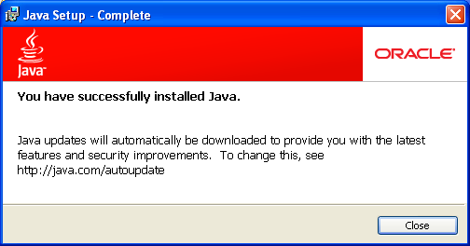
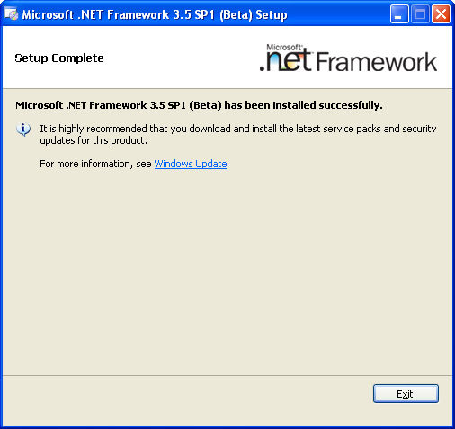

3 Installation Instructions

3.1 Zug installer download

Download the Setup of the latest ZUG package from the Automature FTP site. Please fill up contact information form if needed.

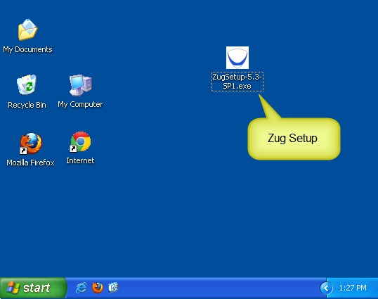

3.2. Initialization of Zug installation

Double Click on the Zug installer icon. The set up starts automatically. The following screen appears.

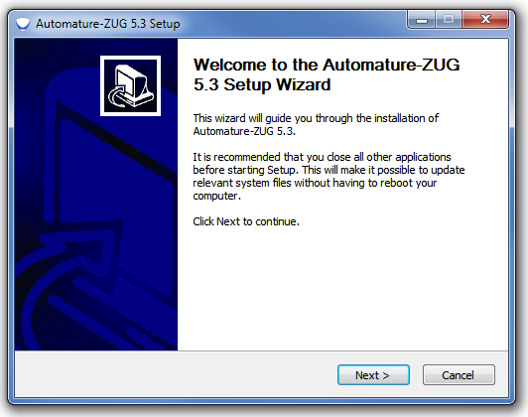

Click on Next. You will be able to view the EULA. If you agree to it, click on I Agree button. If you have any queries regarding EULA, kindly email us at sales@automature.com .

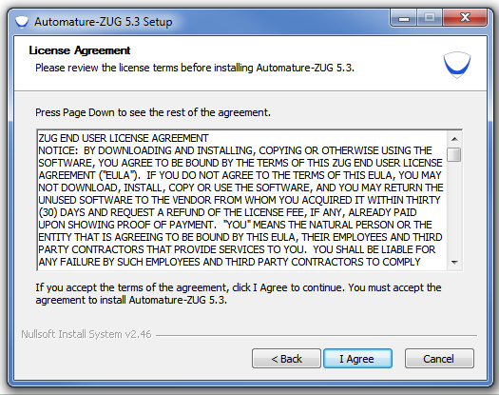

Choose the Java Runtime Environment Path.
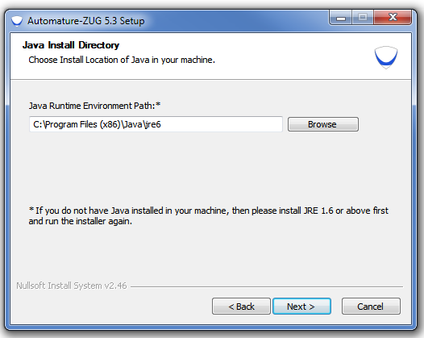

Choose the Destination path for installation of Zug.

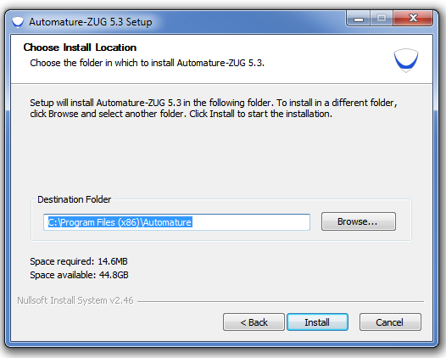

The set up is automatically installed from this point. If you face any problem during the installation kindly contact us at support@automature.com

3.3 Completion of Installation

The following screen will appear once the installation is complete. This means that Zug can be run from anywhere in the command prompt window, one does not need to be in the Zug directory.
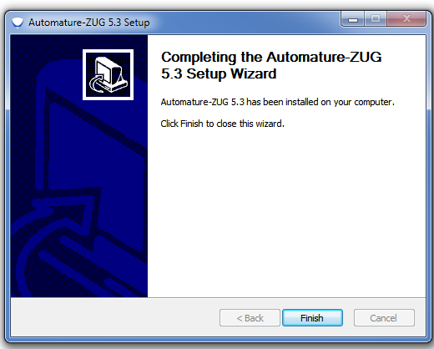
Kindly email the file Config.txt (which is created automatically in your Zug folder) to sales@automature.com to receive the copy of license for Zug ( not for trial version).

3.4 Version Verification

Open a new command prompt window and type: runZUG.bat –version or runzug -v.

This is to verify that the correct version of ZUG has been installed. The version number displayed should match the version number of the package that you downloaded but it will show only if the Licence key is there in the installation directory.
It Promts for No License.key. As in the Screen Shot.
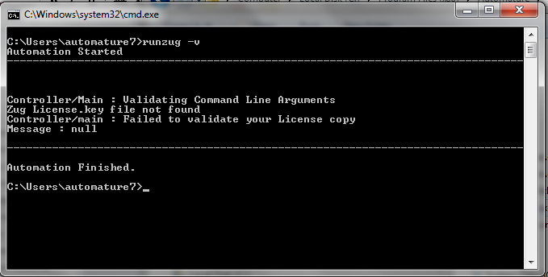

4. License Activation

Once you have successfully installed Zug in your machine, you will have to activate your License in order to use Zug.

Steps to activate your license:

- Download the file Zug license.key, which is provided to you in the email address which you had given in your contact information.
- Place the file in the Zug folder where you installed.

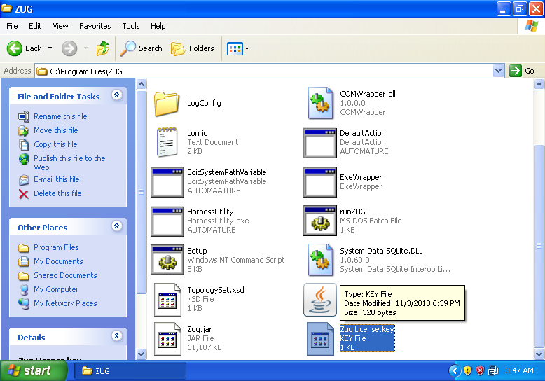
Zug license.key

After Putting the file in the directory it can be checked that what is its version.

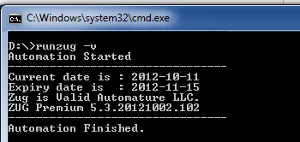

5 Uninstalling Zug

Click on the un-installation icon uninstZug.exe that is present in the Zug installed directory. Zug will be uninstalled automatically.
You can also un-install Zug from Contol Panel as well.
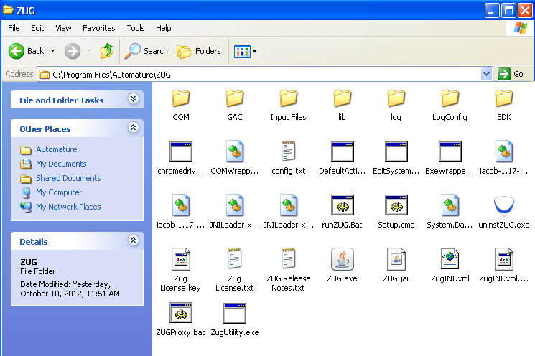

Troubleshooting the Installation
If you see the following errors do the following:
- The prompt appears when running ZugSetup.exe
This application has failed to start because mscoree.dll was not found.
Re-installing the application may fix this problem.
Solution: This is caused when installer is not able to register ZUG API dll. The solution is to install .Net Framework v3.5
- Error message comes up on installation saying
Solution: This is because Microsoft .Net Framework v3.5 folder is missing. The solution is to check and re-install Microsoft Framework v3.5
- ZugSetup.exe executed successfully, but the error message comes up when doing runZUG.bat. The error message is

Error opening registry key ‘Software\JavaSoft\Java Runtime Environment’
Error: could not find java.dll
Error: could not find java SE Runtime Environment
Solution: This is because JRE is missing in system registry. The solution to this is installing required JRE again.

- License key not found in proper place
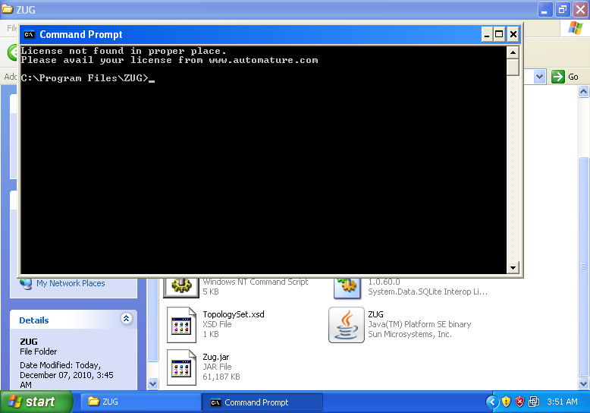

Solution: The license key given to you by email needs to be placed in the folder where Zug is installed. Kindly have a look at the License Activation topic.

- ZugINI.xml configuration
Zug3.0 version now can call the external java jar files as builtin atoms through chur spreadsheet. To make it happen the ZugINI.xml parsing is need. Inside the Zug installation directory the ZugINI.xml file can be edited to by putting the values in the tags of
<inprocesspackages>
<inprocesspackage name="">
<file-path></file-path>
<jar-package></jar-package>
<class-name></class-name>
</inprocesspackage>
</inprocesspackages>
if no value is written then it will show a warning message while running the ZUG automation.
If ZUOZ is installed after ZUG installation then this part will be configured by ZUOZ installer.
- JRE Dependency
If the JRE is updated from java 1.6 to java 1.7 after installing ZUG then ZUG will stop working and it will give an error message similar to the message given below
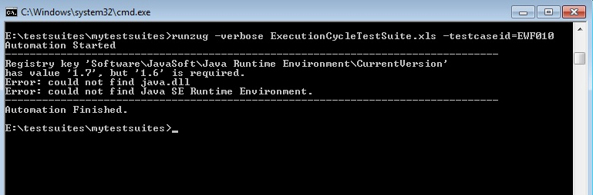

Solution: Reinstalling ZUG will fix the problem
- For further problems visit ZUG Forum.

